BC817-40 NPN
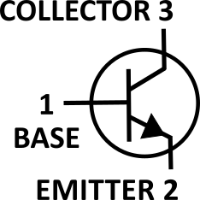
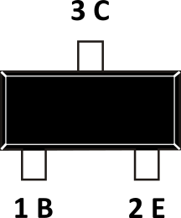
General purpose switching and amplification
V_{CBO} = 50 V f_{T} = Typ. 100 MHz
V_{CE0} = 45 V V_{BE(sat)} = 1 V
V_{EBO} = 5 V P_{C}= 310 mW
I_{C} = 800 mA T_{STG} = -65 ~ 150 °C
h_{FE} = 250 min. / 600 max.

